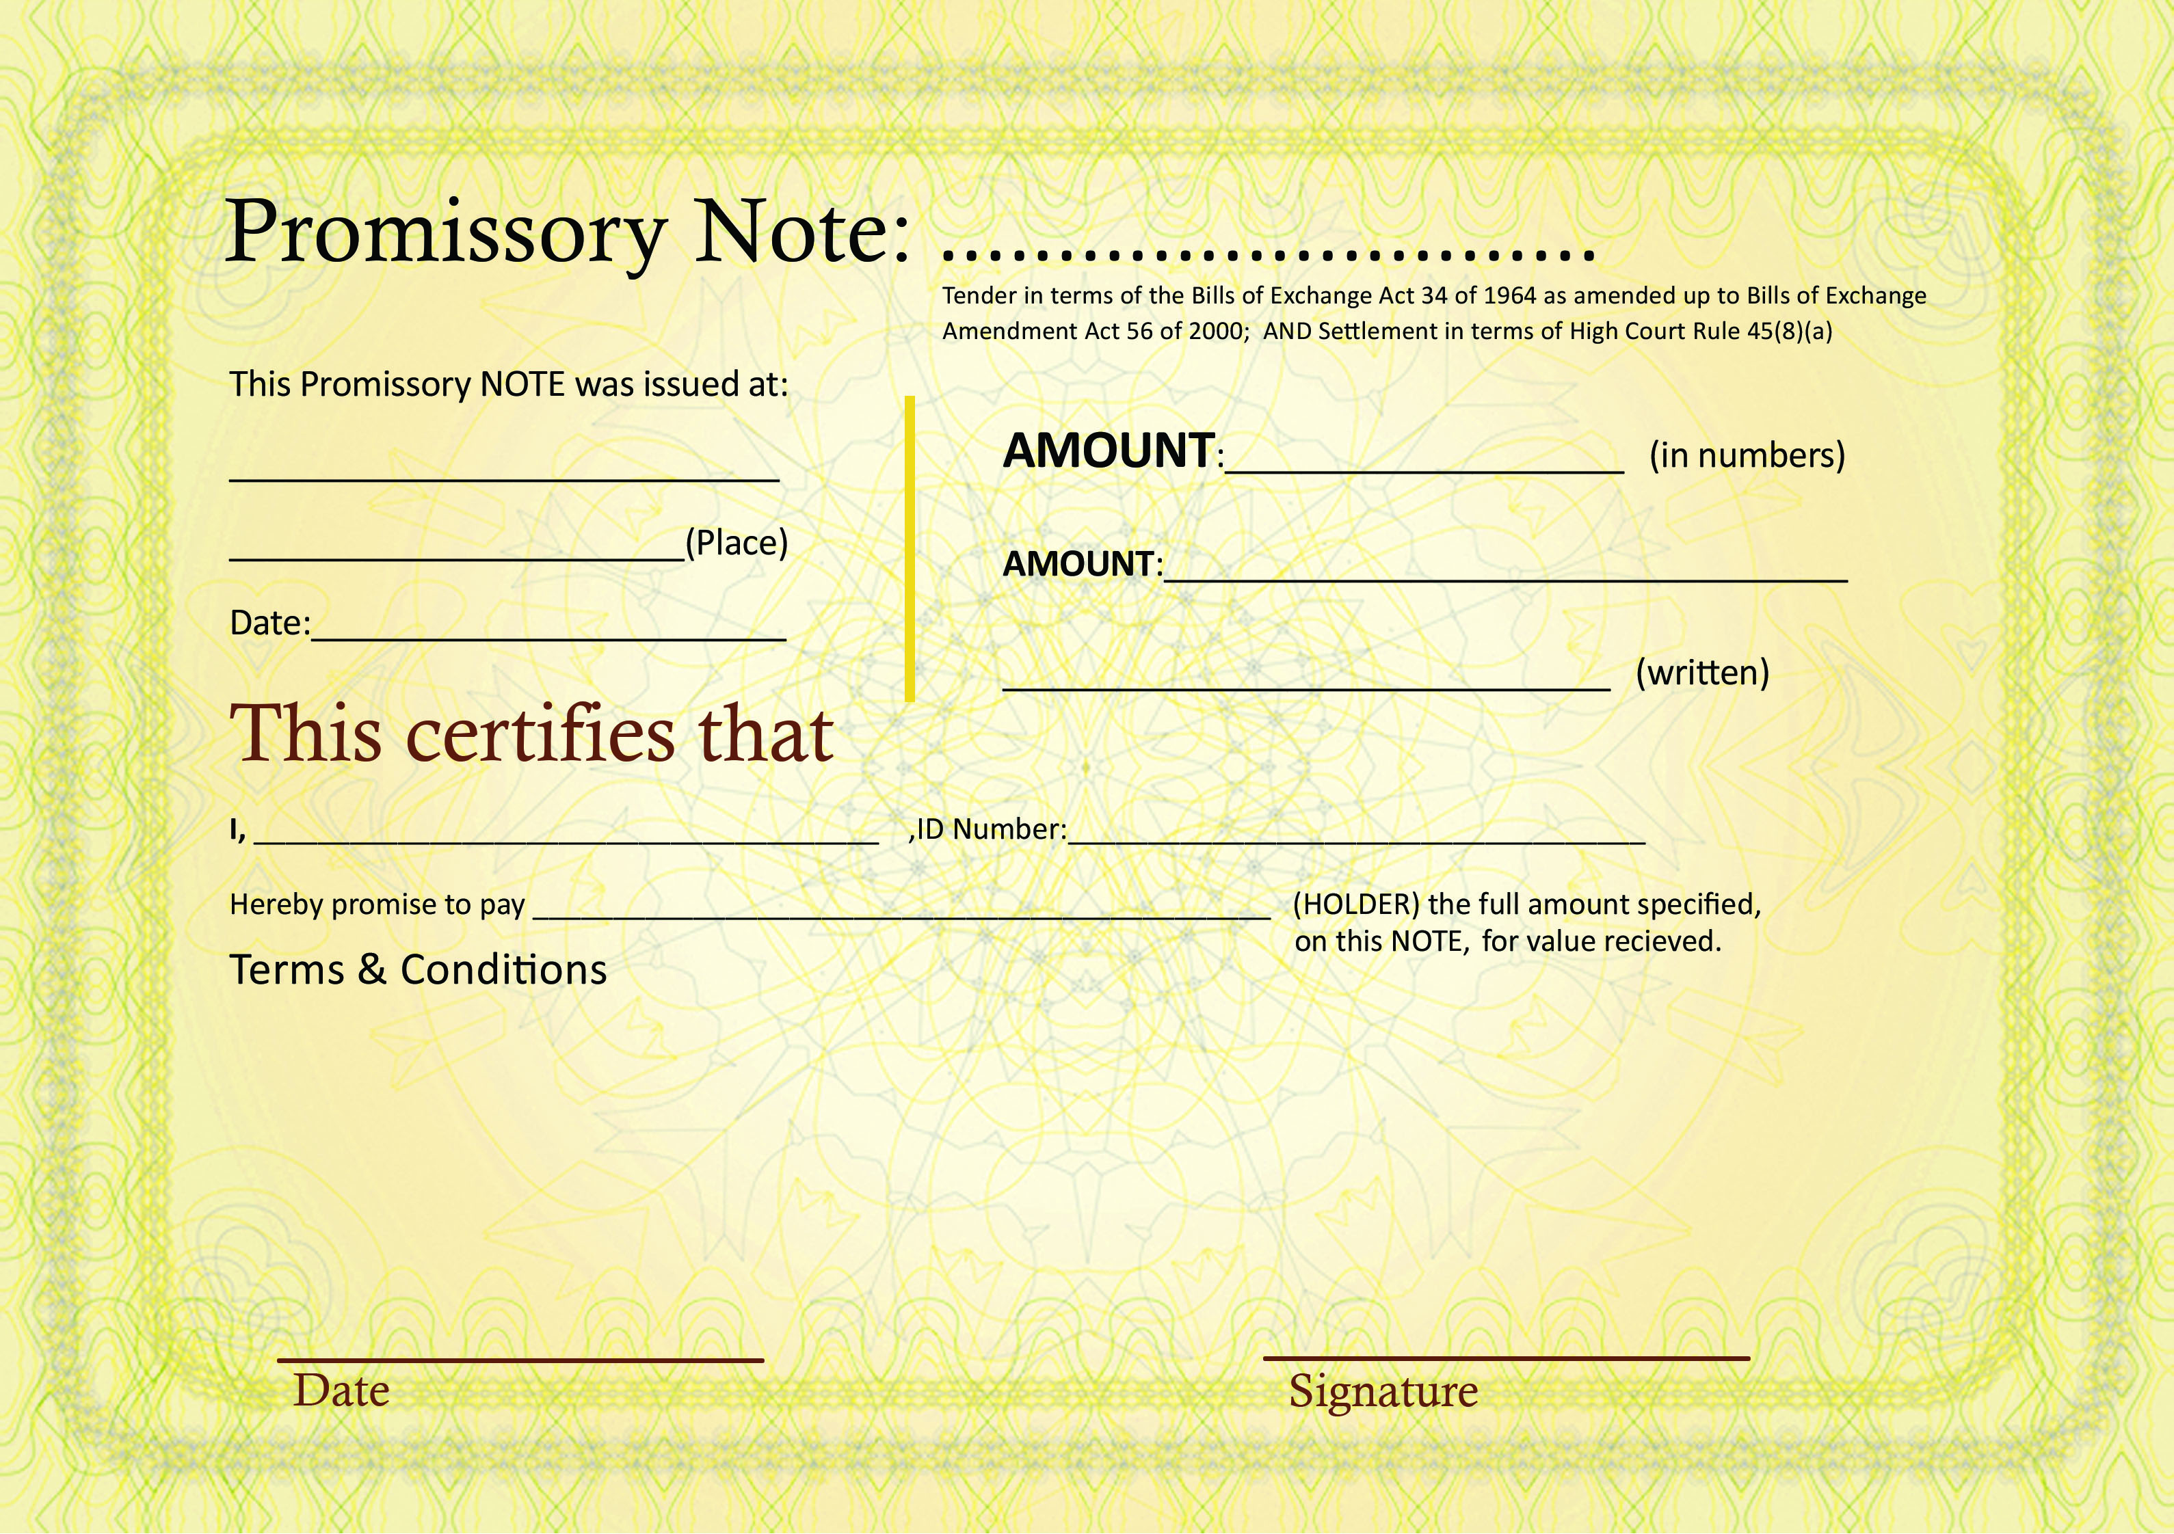

**NO: MJTPN004**

The payment will be made in monthly instalments of R 500 (five hundred rand) per month, on the 7th (seventh) day of every consecutive month until the obligation has been fulfilled. The payment can be obtained by the HOLDER at 17 ZASM ROAD WATERVAL BOVEN, MPUMALANGA. I hereby give permission to the HOLDER and/or the HOLDER IN DUE COURSE of this Promissory Note, to use this NOTE in any way necessary as a negotiable instrument to be financially traded on; whereas such trade shall terminate the obligation herein.

**Waterval Boven**

**Mpumalanga**